**IIS Settings for Windows Applications**

* Create application pool with .NET CLR Version v4.0.30319 and Managed pipeline mode as “Integrated”

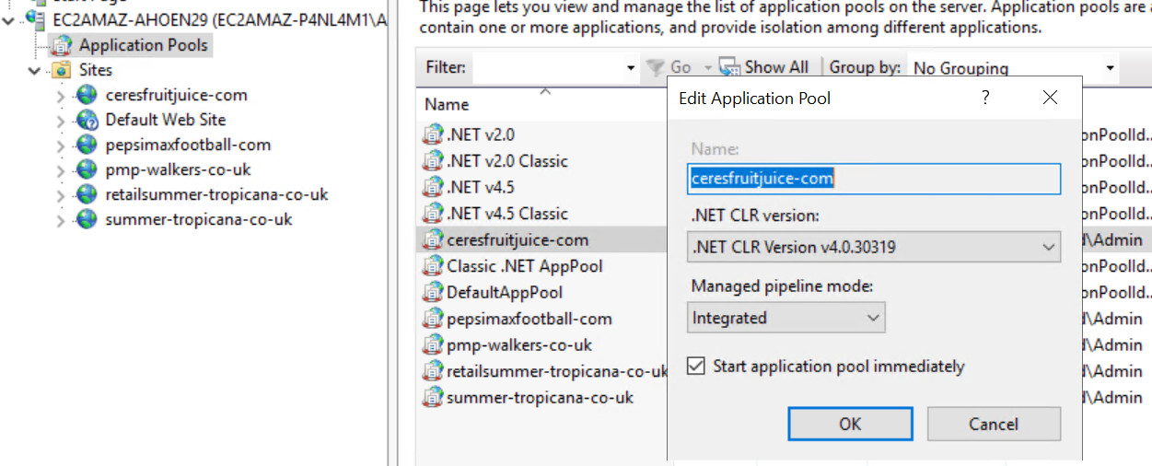

* Click Advance Settings for the application pool selected, change “ApplicationPoolIdentity” to custom account

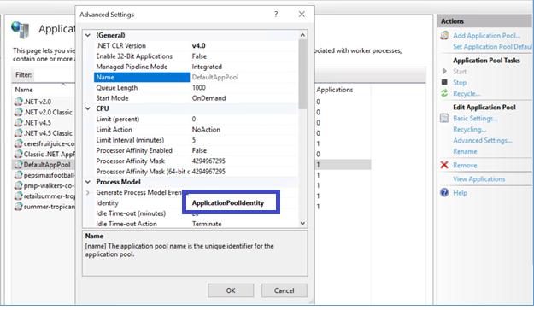

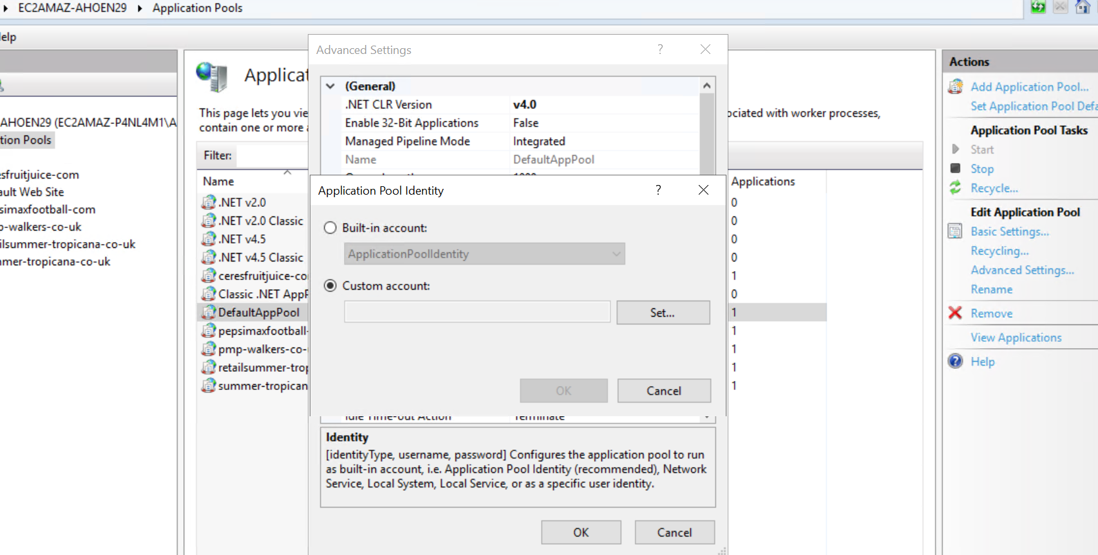

* Enter FSx credentials with domain, click ‘Ok’

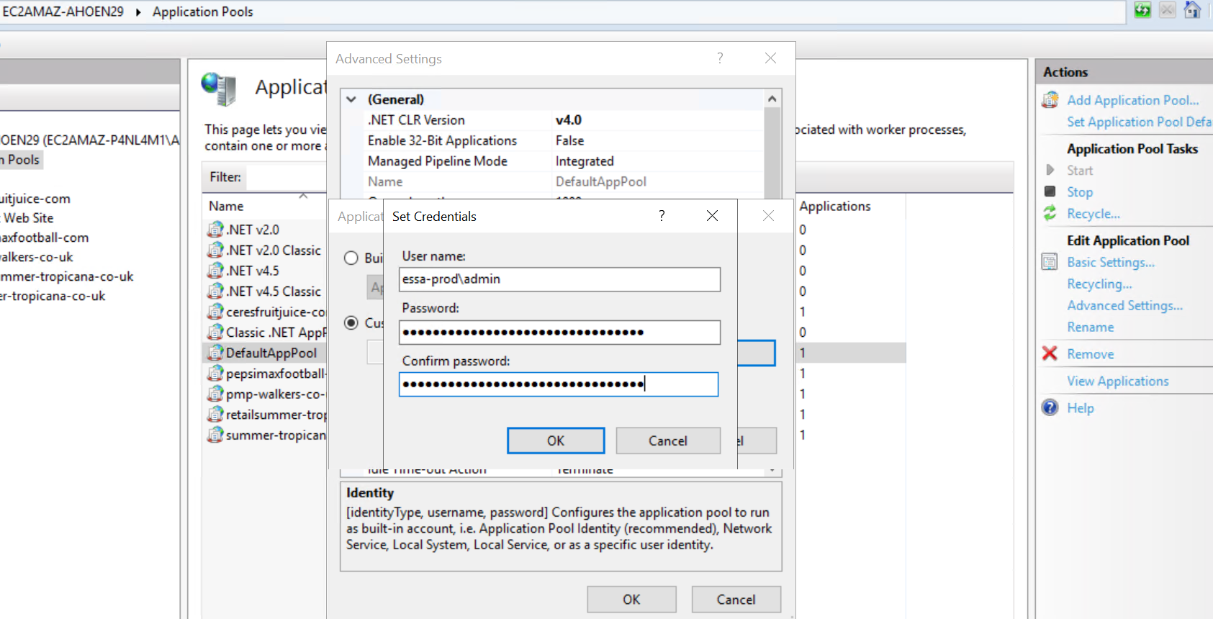

* Change Idle Time-Out from 20 to 0

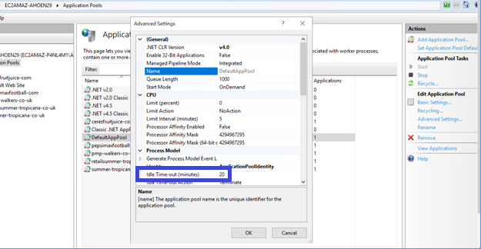

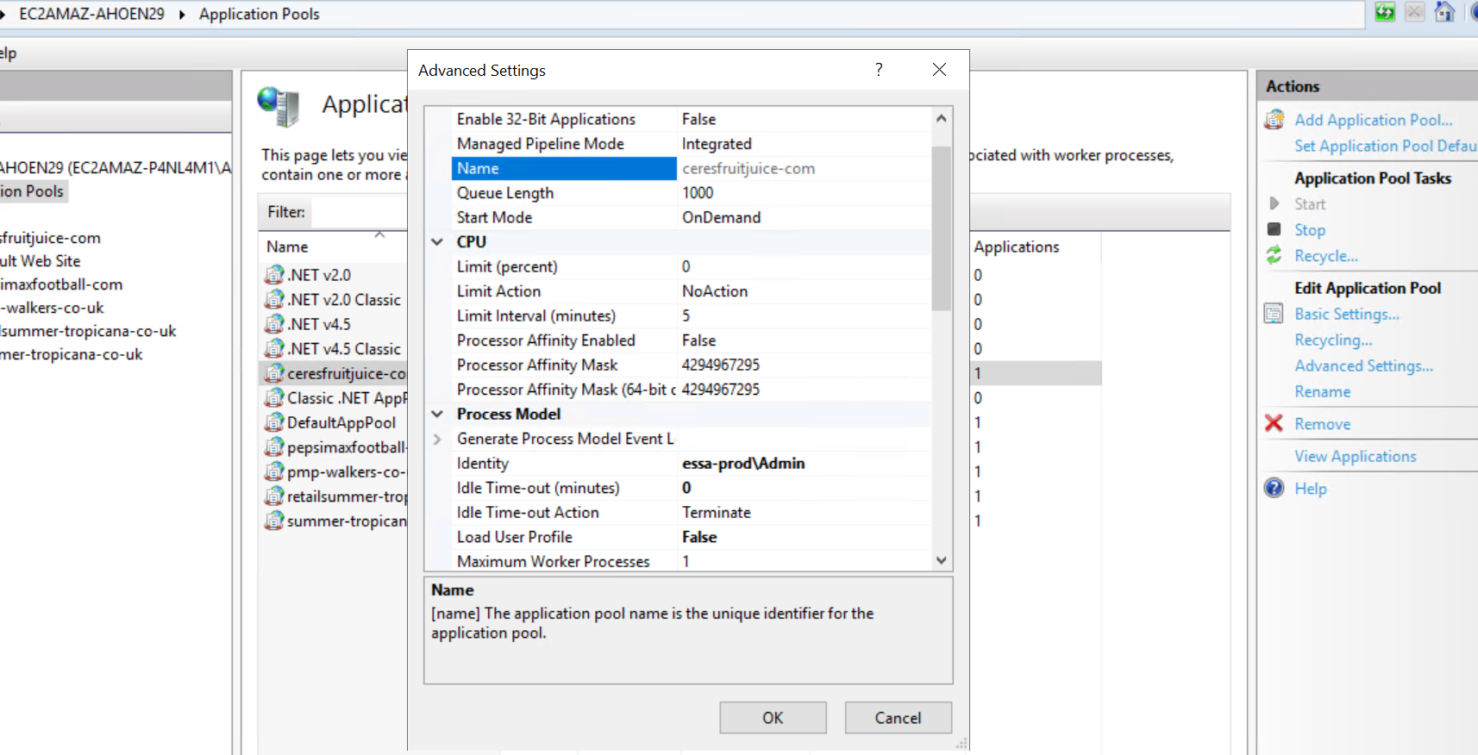

* Change ‘Regular Time Interval’ from 1740 to 0, click ‘Ok’

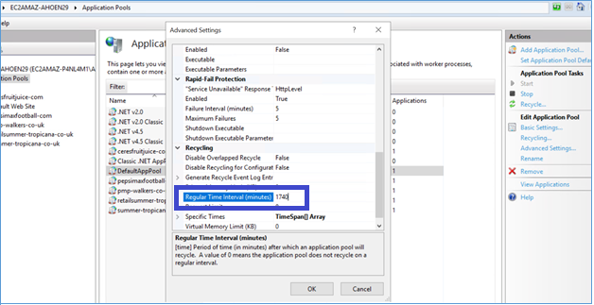

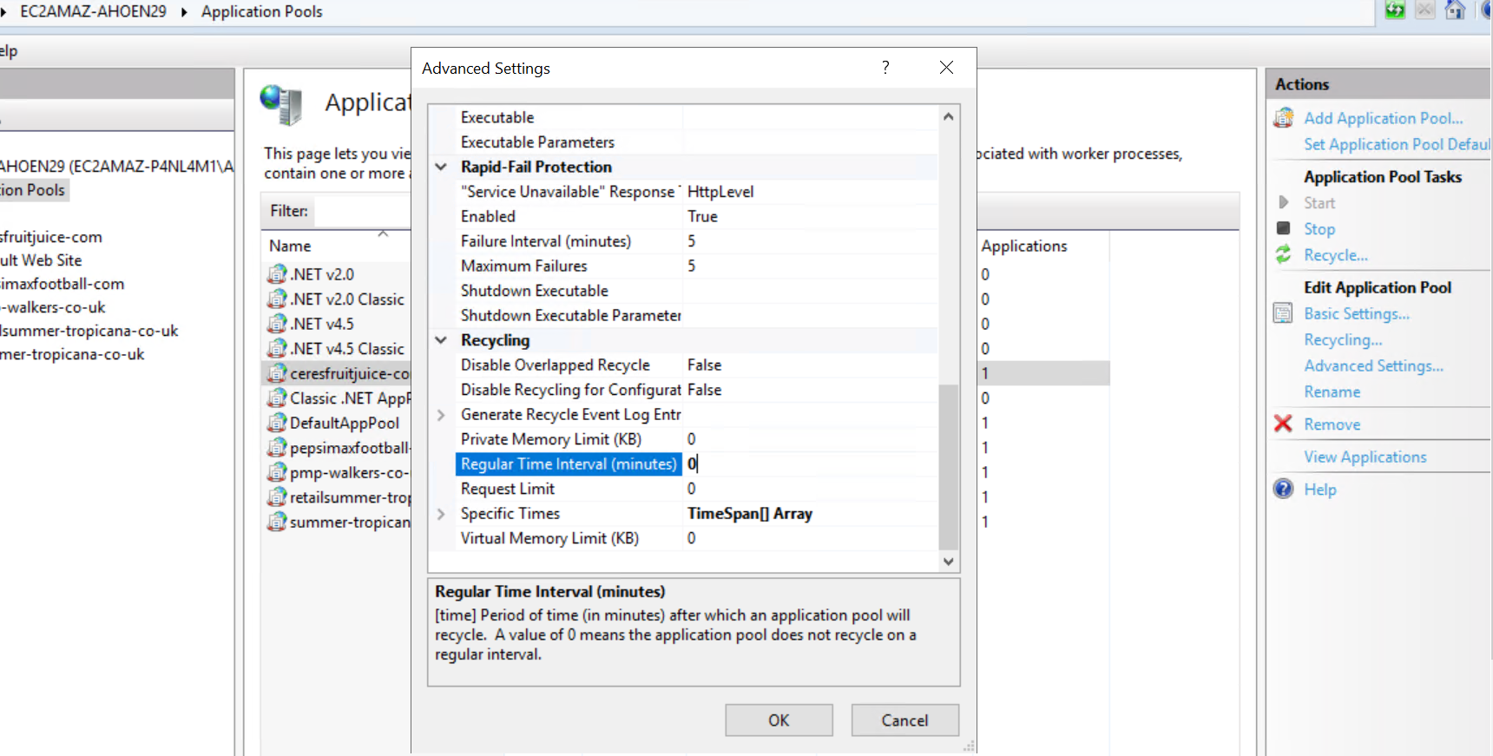

* Validate Website settings 🡪 Click ‘Basic Settings’ and then click ‘Test Settings’ to confirm FSx path is accessible.

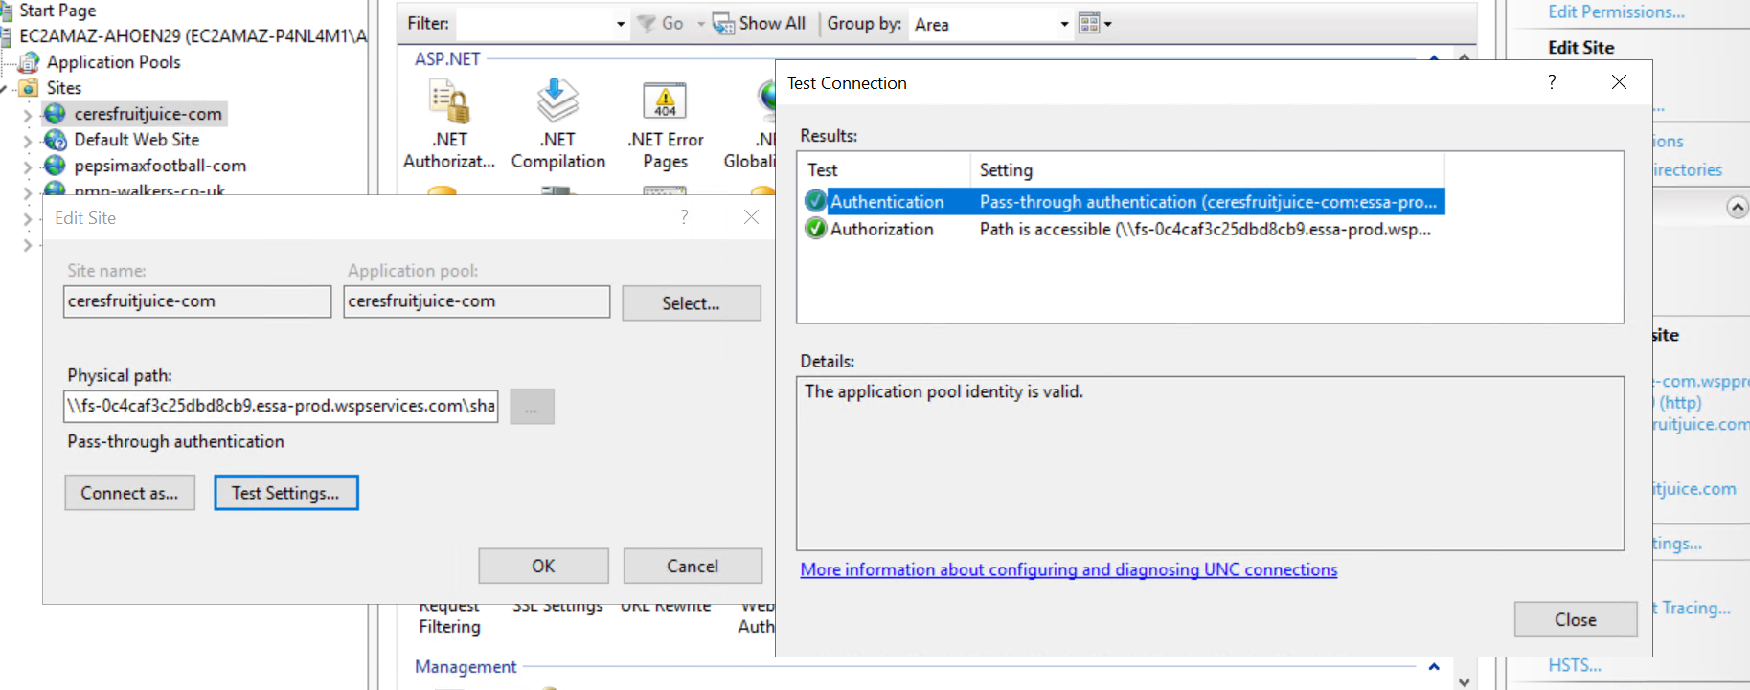

* Add the required bindings

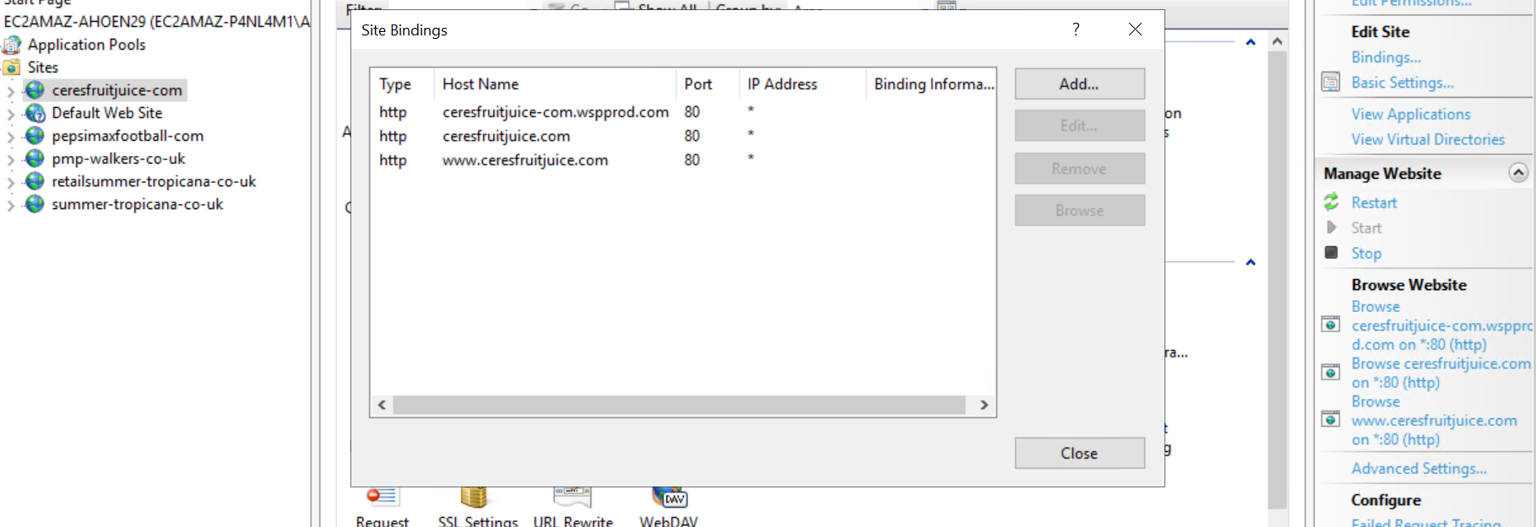

* Schedule Application Pool Recycle on daily basis  
    
  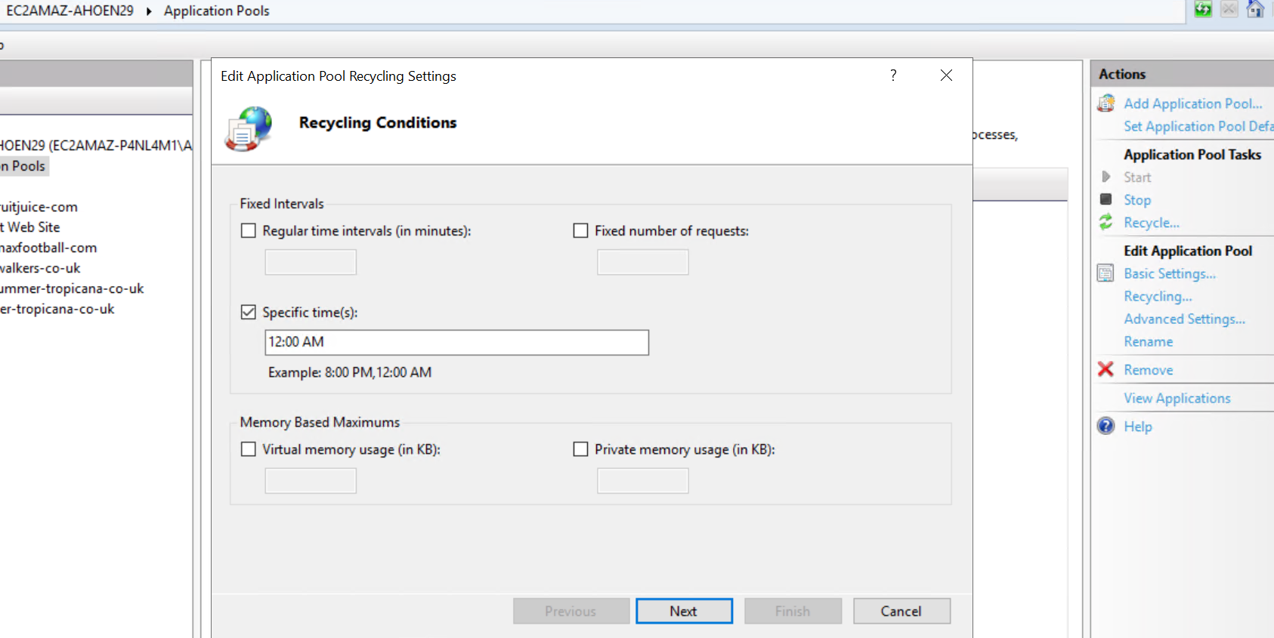

Please find the list of **IIS Server Roles/Features** installed on Instances

**IIS URL Rewrite Module 2 - To be installed using exe**

**Server Roles**

* File and Storage Services (1)
  + Storage Services
* Web Server (IIS) Installed
  + Web Server (All)
  + FTP Server (All)
  + Management Tools (All)

**Features**

* + .NET Framework 3.5 Features (All)
  + .NET Framework 4.7 Features (All)
  + Message Queuing (1)
    - Message Queuing Services
      * Message Queuing Server
  + System Data Archiver
  + Windows Defender Antivirus
  + Windows Identity Foundation 3.5
  + Windows PowerShell (3)
    - Windows PowerShell 5.1
    - Windows PowerShell 2.0 Engine
    - Windows PowerShell ISE
  + Windows Process Activation Service (All)
  + WoW64 Support
  + XPS Viewer